**Title: Linux Command List Assessment**

**Name:** K.Ashfaaq Ahamed

**Date:** 19-05-2023

**Regs_No:** 20BCN7025

**Campus:** VIT-AP

**File and Directory Operations:**

**ls:** List files and directories

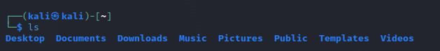

cd: Change directory



pwd: Print working directory

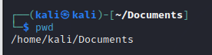

mkdir: Make directory

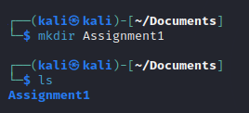

touch: Create an empty file

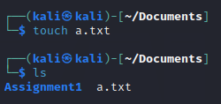

cp: Copy files and directories

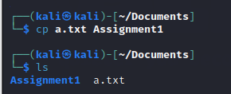

mv: Move or rename files and directories

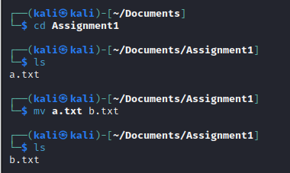

rm: Remove files and directories

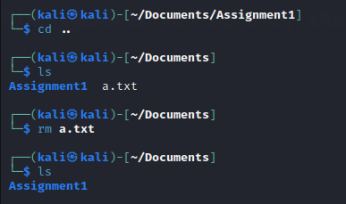

find: Search for files and directories

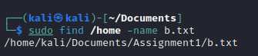

**File Viewing and Editing:**

cat: Concatenate and display file content

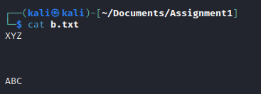

less: View file content with pagination



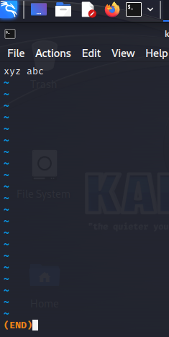

head: Display the beginning of a file

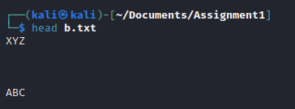

nano: Text editor for creating and editing files



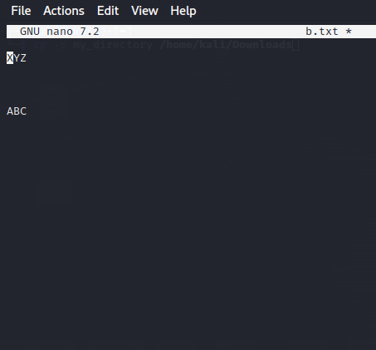

vi/vim: Powerful text editor for experienced users

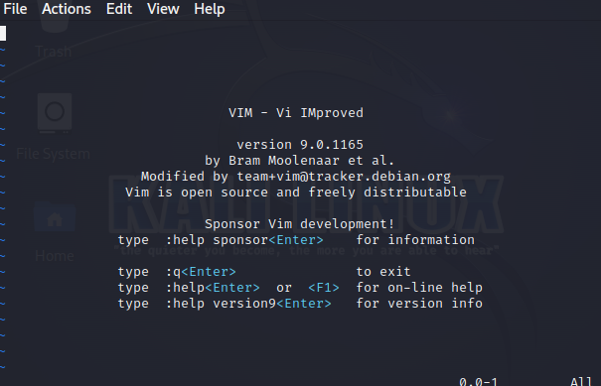

**File Permissions:**

chmod: Change file permissions



chown: Change file owner

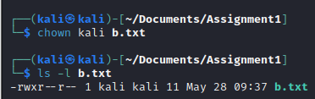

chgrp: Change file group

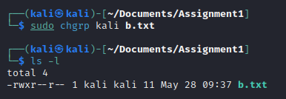

**File Compression and Archiving:**

tar: Archive files

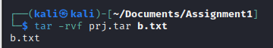

gzip: Compress files



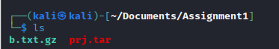

unzip: Extract files from a ZIP archive

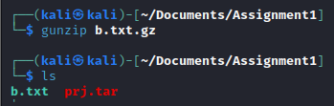

**Process Management:**

ps: List running processes

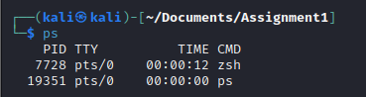

top: Display real-time system information and processes

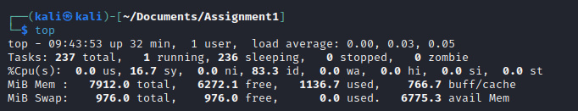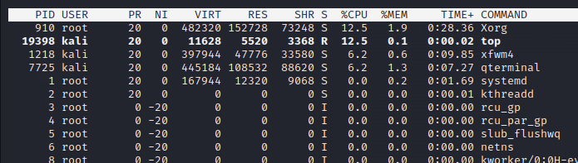

Kill: Terminate processes



bg: Run processes in the background

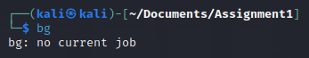

fg: Bring background processes to the foreground

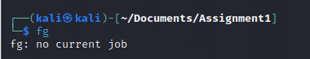

**System Information:**

uname: Print system information

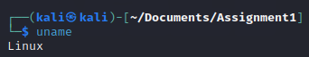

df: Display disk space usage

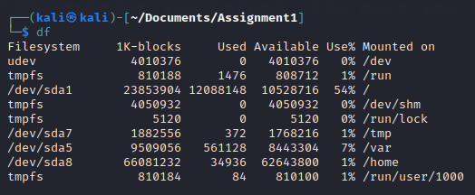

free: Display memory usage

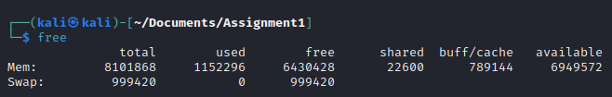

uptime: Show system uptime

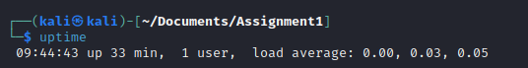

who: Display logged-in users

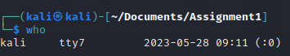

w: Display logged-in users and their activities

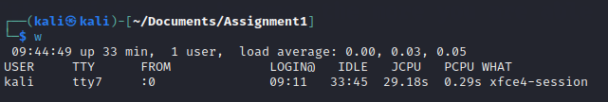

**Networking:**

ifconfig: Configure network interfaces

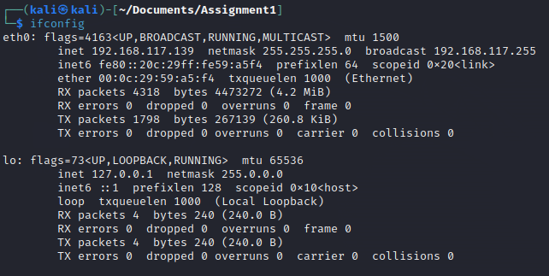

ping: Send ICMP echo requests to a network host

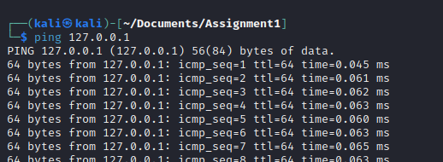

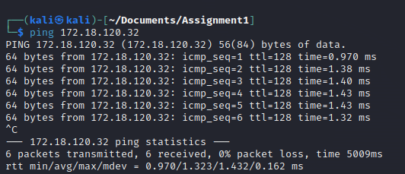

ssh: Securely connect to a remote system

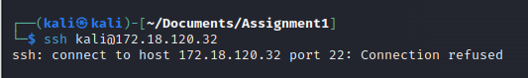

wget: Download files from the web

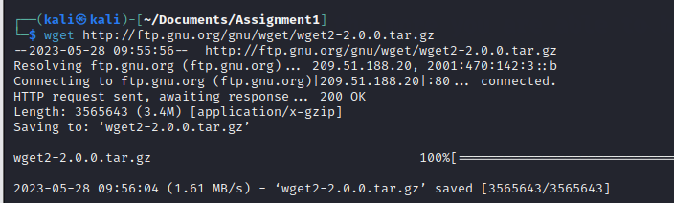

**System Administration:**

sudo: Execute commands with superuser privileges

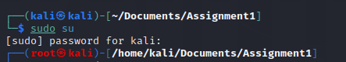

apt-get: Package management for Debian-based distributions

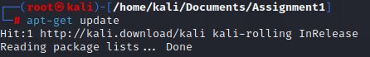

yum: Package management for Red Hat-based distributions

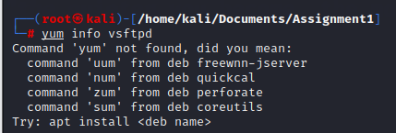

systemctl: Manage system services

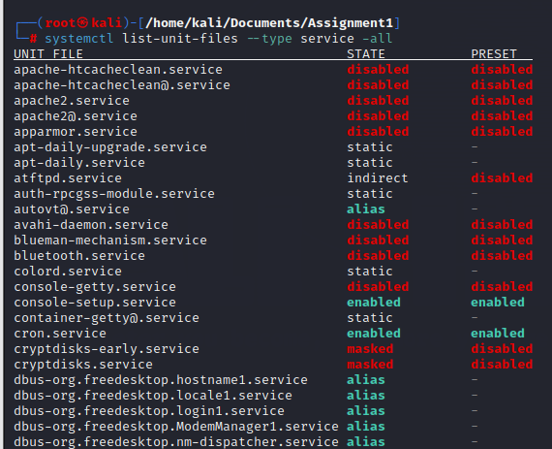

crontab: Schedule recurring tasks

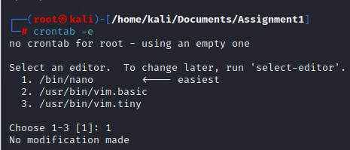

useradd: Add a new user



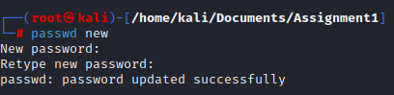

passwd: Change user password

